Public transportation optimization in IoT can involve various algorithms and techniques depending on the specific goals and challenges of the transportation system. Here are some commonly used algorithms and methods for optimizing public transportation using IoT:

**Dijkstra's Algorithm**: Dijkstra's algorithm is a widely used algorithm for finding the shortest path between nodes in a graph. In public transportation optimization, this algorithm can be used to find the most efficient routes between bus stops or train stations.

**Algorithm for Public Transportation Optimization on IOT**:

**Step 1**: Data Collection

1.1. Deploy IOT devices on vehicles: Equip public transportation vehicles (buses, trams, trains) with IoT sensors and devices to collect real-time data. These devices can include GPS, accelerometers, temperature sensors, and cameras.

1.2. Install IoT infrastructure: Set up IoT infrastructure like sensors at stops, traffic signals, and other relevant locations to monitor traffic, weather, and passenger counts.

**Step 2**: Data Integration and Processing

2.1. Data Ingestion: Collect and process data from IoT devices, including vehicle location, speed, passenger load, environmental conditions, and traffic information.

2.2. Real-time Data Analysis: Use cloud computing or edge computing to analyze data in real-time to make immediate decisions.

**Step 3**: Route Optimization

3.1. Dynamic Routing: Use algorithms such as Dijkstra's or A* to dynamically optimize vehicle routes based on real-time traffic conditions, passenger demand, and road closures.

3.2. Predictive Analytics: Utilize historical and real-time data to predict future demand and traffic patterns for route planning.

**Step 4**: Passenger Information and Experience Enhancement

4.1. Mobile Apps and Information Displays: Develop mobile applications and information displays at stops and inside vehicles to provide real-time updates on vehicle locations, estimated arrival times, and any disruptions.

4.2. Passenger Load Balancing: Use data on passenger loads to dispatch additional vehicles during peak hours and optimize service frequency.

**Step 5**: Maintenance and Safety

5.1. Predictive Maintenance: Monitor vehicle health and predict maintenance needs using IoT data to prevent breakdowns and improve safety.

5.2. Safety Alerts: Implement safety alerts for drivers and passengers, such as collision warnings and emergency services integration.

**Step 6**: Energy Efficiency

6.1. Energy Monitoring: Monitor vehicle energy consumption using IoT sensors and algorithms to optimize routes and reduce fuel consumption.

6.2. Eco-friendly Alternatives: Suggest eco-friendly routes or public transportation modes like electric buses when possible.

**Step 7**: Environmental Considerations

7.1. Air Quality Monitoring: Use IoT sensors to monitor air quality and provide alternate routes if there are pollution hotspots or environmental hazards.

7.2. Green Initiatives: Promote green transportation options and incentivize their use.

**Step 8**: Feedback Loop and Machine Learning

8.1. Continuous Learning: Implement machine learning models that learn from historical and real-time data to improve the efficiency of public transportation services over time.

**Step 9**: Emergency Management

9.1. Crisis Response: Utilize IoT data to respond to emergencies or natural disasters by rerouting vehicles and ensuring passenger safety.

**Step 10:** Cost Optimization

10.1. Cost Analysis: Monitor and analyze the operational costs of the public transportation system and make adjustments to optimize the budget.

**Step 11:** Reporting and Analytics

11.1. Generate reports and dashboards for transportation authorities to assess the performance of the system, track key metrics, and identify areas for improvement.

**Step 12:** Accessibility and Inclusivity

12.1. Ensure that the system caters to the needs of all passengers, including those with disabilities, by providing real-time accessibility information and adapting services as necessary.

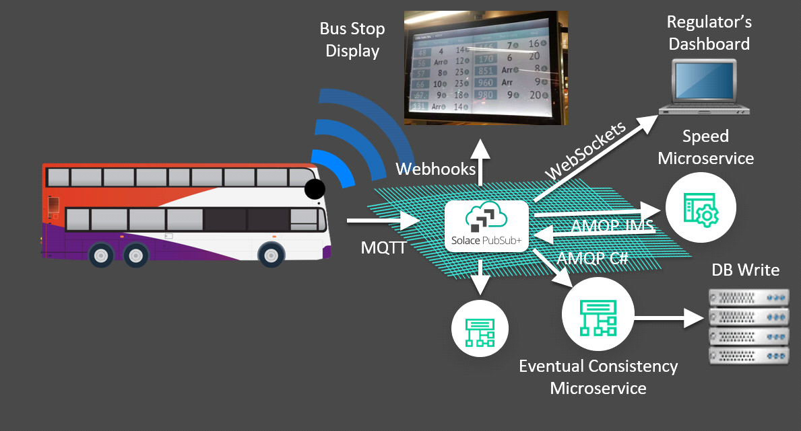

**CONCLUSION OF ALGORITHM:**

This algorithm provides a high-level overview of the steps and considerations involved in optimizing public transportation using IOT. Implementing such a system requires collaboration between transportation authorities, technology providers, and data scientists, along with continuous improvement and adaptation based on the gathered data and changing urban dynamics.